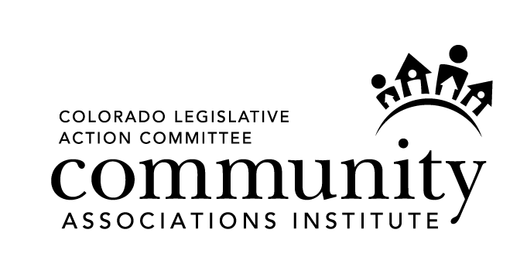

What You Need to Know About House Bill 1343
The “Manager Licensure Clean-Up Bill”

CAI’s Colorado Legislative Action Committee (“CLAC”) is proud to report that House Bill 1343 (“HB 1343”), which cleans-up the manager licensure law in Colorado, unanimously passed the Colorado House of Representatives and Senate. In a legislative session that was punctuated by partisan politics, that’s saying something! As soon as Governor Hickenlooper signs the bill into law, which may be as soon as this week, HB 1343 will immediately become effective. Here’s what you need to know about HB 1343:

● The bill clears up who is required to be licensed as a Community Association Manager (“CAM”) and who is not required to be licensed.

● CEOs of management companies who do not engage in community association management and are not the Designated Manager for their companies, are not required to be licensed as CAMs.
● An employee of a management company, working under the supervision of a licensed CAM, is not required to be licensed if that employee performs clerical, ministerial, accounting or maintenance functions.
● An employee of a common interest community who only performs clerical, ministerial, accounting or maintenance functions is not required to be licensed as a CAM.
● An independent contractor who only performs clerical, ministerial, accounting or maintenance functions, and who does not perform community association management functions, is not required to be licensed.
● An individual holding an Apprentice License and who is working under the direct supervision of a CAM, is not required to be licensed as a CAM during the period of time their Apprentice License is in effect (1 year).

● The bill clarifies that there are two parts of the CAM licensure exam. The “General Portion” of the exam measures the competency of CAMs to carry out the core functions of community association management. The “Colorado Law Portion” of the exam measures the basic understanding of CAMs of governing documents and Colorado law which they are required to comply with.

● CAMs who hold in good standing the CMCA credential, AMS designation, PCAM designation or any other designation recognized by the Director of the Division of Real Estate, are only required to take and pass the Colorado Law Portion of the licensure exam.

● For CAMs who have not passed the licensure exam by July 1, 2015, the Director of the Division of Real Estate has the authority to grant those CAMs a Provisional License through December 31, 2015. Shortly after HB 1343 is signed into law, we expect the Division of Real Estate to issue Emergency Rules addressing qualifications and procedures for obtaining a Provisional License.

● Individuals who are new to community association management may apply for
an Apprentice License for the purpose of learning and performing any practices that require a CAM license. Individuals who are granted an Apprentice License must at all times work under the direct supervision of a licensed CAM. The Apprentice License will be good for a period of one (1) year and is not subject to renewal. Shortly after HB 1343 is signed into law, we expect the Division of Real Estate to issue Emergency Rules addressing qualifications and procedures for obtaining an Apprentice License.

When HB 1343 is signed into law and when the Division of Real Estate publishes Emergency Rules addressing the Provisional License and Apprentice License, CLAC will send an email updates to all manager members of CAI.

If you would like to be added to CLAC’s contact list, please send
an email to: info@cai-clac.com

